Assignments for 5/25/20- 6/9/20

DEAR FAMILIES,

THIS IS OUR LAST KINDERGARTEN PACKET. IT HAS 2 WEEKS WORTH OF WORK TO IT AS WE ARE MAKING SURE STUDENTS HAVE TIME TO COMPLETE AND HAND BACK IN. WE ARE ALL SO PROUD OF YOU! SEE YOU NEXT YEAR!

WE MISS YOU AND HAVE A GREAT SUMMER!

SENDING LOVE,

MRS. PICCIRILLO, MISS AVERSA, MISS EVERTS, & MRS. JONES

Student material pick up from school for Kindergarten is May 29th from 9:30 - 11:00 A.M.

Last day to hand in any work for students is June 9, 2020. This is the students last day of school this year!

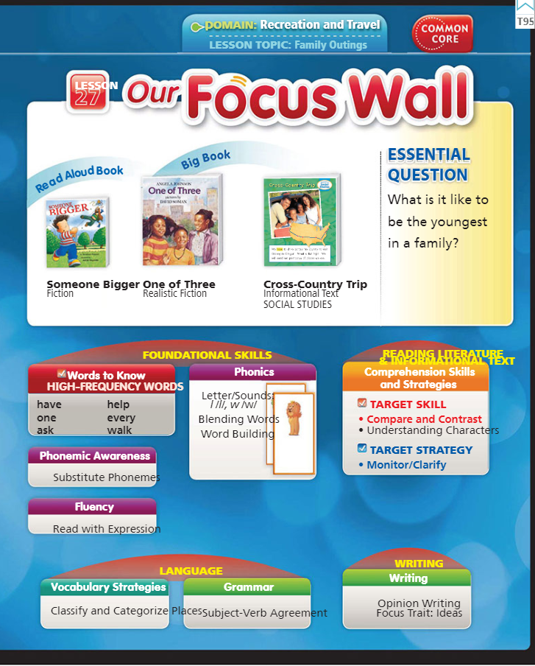

This weeks Topic: Family Outings

Have students discuss the type of family outing they like to go on. Where do you like to go with your family? What do you like to do? Where would you like to go that you have not gone before with your family?

Our new sight words: ask, every, have, help, one, walk

Read Aloud Book: Someone Bigger

Listen here: https://www.youtube.com/watch?v=fz7cabQyJh8

Big Book: One of Three

Listen here: https://www.youtube.com/watch?v=LhYctuRBFo8

ELA-

- Click below to listen to the story online- Someone Bigger

https://www.youtube.com/watch?v=fz7cabQyJh8

- Writing- Write about your favorite part of the story. Why was that your favorite part?

(EXAMPLE: My liked the part when _______. I liked it because ________. )

(EXAMPLE of a picture to match: draw a picture of a their favorite part)

- 5 minutes of fun ELA from our ELA page

Sight words- ask, every, have, help, one, walk

Suggestions for Sight Words-

Practice writing words, use them in a sentence, do a word hunt in your favorite book, write them on flash cards!

Math-
- Practice writing your numbers 1-100
- Count out loud to a family member from 1-100
- Complete this 3D Shape Match
- Complete this Adding and Subtracting Sheet
- Complete this Count How Many Sheet
- Watch the 3D Shape Video- https://www.youtube.com/watch?v=zPZegz690Mg

FUNdations-
CVC-e Review-
https://www.youtube.com/watch?v=SUp-nnGusvk
Practice tapping out, reading, & writing CVC-e words- Review all long vowel Sounds
Vote
Cane
Time
Hike
Bake
Puke
Role
-Practice these Review CVC-e Words Here
- Do this Missing Super E Sheet –
- Do this Super E Bubbles Review Sheet

Science-
Shady Structures At Home Science Project
